Heavens Hoofprints Equestrian Center
31050 Burlwood Dr., Castaic, Ca. 91384 661-645-0278 HeavensHoofprints@yahoo.com HeavensHoofprints.org
Heavens Hoofprints Summer Camp 2019
Camp Time: 9am- 1pm daily, Monday through Friday
Campers Age: 6-14 years old
Weekly Camp Cost: $250
____Week 1: June 17-21 World Culinary Delights and Equestrian Adventures
____Week 2: June 24-28: Magical Horses and Sweet Enchantment
___Week 3: July 15-19: Cowboys and Cowgirls In Christ
___Week 4: July 22-26: Gallant Champions of Medieval Times
___Week 5: July 29-August 2: Dance, Ride, Sing to Your Horses Heart Beat
___Week 6: August 5-9: Superheroes on their Super Horses

Participants Name: _________________ Age: ____ Student Ht: ___ Student Wt:____
Parent/ Guardian Name(s): ________________________________________________
Participants Address: _____________________________________________________
Parent/ Guardian Home #: ___________ Cell #: __________ Emergency #: __________
Alternative Emergency Contact: _____________________ Phone #: ____________
If your child has any special needs or accommodations that need to be noted, please provide that in the space provided.________________________________________________________________________________________ __ ________________________________________________________________________________________
-We recommend wearing sunscreen and hats to protect your child from the sun. All participants must bring their own water and snack. -We will provide time for snack break and the participants will have access to their water at all times. -Please note that while at camp participants will get dirty and possibly wet from water, so please send them in clothes that can get dirty! -We will be taking lots of pictures and will share your child’s pictures with you by e-mail or hard copy.
-If you consent to having your child’s pictures shared among Heavens Hoofprints Equestrian Center’s different mediums (i.e. website, flyers, bulletin board, etc.) please initial here.______

Heavens Hoofprints Equestrian Center Riding Agreement
Release of Claims and Indemnity Agreement
The undersigned being of lawful age, desires to participate in equestrian activities with Heavens Hoofprints Equestrian Center located at 31050 Burlwood Dr., Castaic, Ca. 91384. The undersigned acknowledges that there are dangers and risks of injury inherent in these equestrian activities, but still desires to participate in these activities.
THEREFORE, the undersigned, for and in consideration of the opportunity to participate in these equestrian activities and for other good and valuable consideration, does hereby forever release, acquit, and forever discharge company, individuals, their employees, agents, and all other persons, corporations, associations, or partnerships in any way involved in said business or the ownership of land or personal property used in said business from any and all claims, actions, causes of action, demands, rights, damages, and costs whatsoever which the undersigned may have or incur on account of, or in any way growing out of, any and all known and unknown, foreseen and unforeseen, bodily and personal injuries and/ or property damage or the consequences thereof resulting from any accident, casualty or event involving the undersigned and arising out of equestrian activities.
IT IS EXPRESSLY UNDERSTOOD by the undersigned that the undersigned would not be permitted to engage in equestrian activities without this release whereby the undersigned, regardless of fault, agrees to fully release the releasee from any and all responsibility of accident or injury.
IT IS ACKNOWLEDGED THAT PROTECTICE HEAD GEAR IS TO BE WORN AT ALL TIMES WHEN PARTICIPATING IN ANY EQUESTRIAN ACTIVITY. RIDER’S WHO REFUSE TO WEAR PROTECTIVE HEAD GEAR WILL NOT BE ALLOWED TO PARTICIPATE IN ANY EQUESTRIAN ACTIVITIES.
FURTHER, in the consideration of allowing me to participate in such activities, the undersigned hereby expressly agrees to indemnify and save harmless the releasee from any and all claims or damages, (including cost and expenses of defending any claims or lawsuits) which might be made against releasee by reason of , or in any way arising out of such equestrian activities, including any claims or losses to or caused by other riders, users, guest, invitees, or persons incidentally involved in activities or on said premises, or any combination thereof.
The undersigned further declares and represents that no promise, inducement, or agreement not herein expressed had been made to the undersigned and that this release contains the entire agreement between two parties hereto and that the terms of this release are contractual and not a mere recital.
THE UNDERSIGNED HAS READ THE FOREGOING RELEASE AND FULLY UNDERSTANDS IT.
Date this______ day of __________, 20__ *If under 18, Parent/ Guardians Signature Required*
Rider’s Name: ____________________________Rider’s Age: _____ Riders Experience: BEG. /INT. /ADV. (circle one)
Rider /Parent Signature* (if under 18)___________________________ _____________________________
Rider/ Parent Phone Number: ____________________
Address: ____________________________________________ E-Mail:________________________________

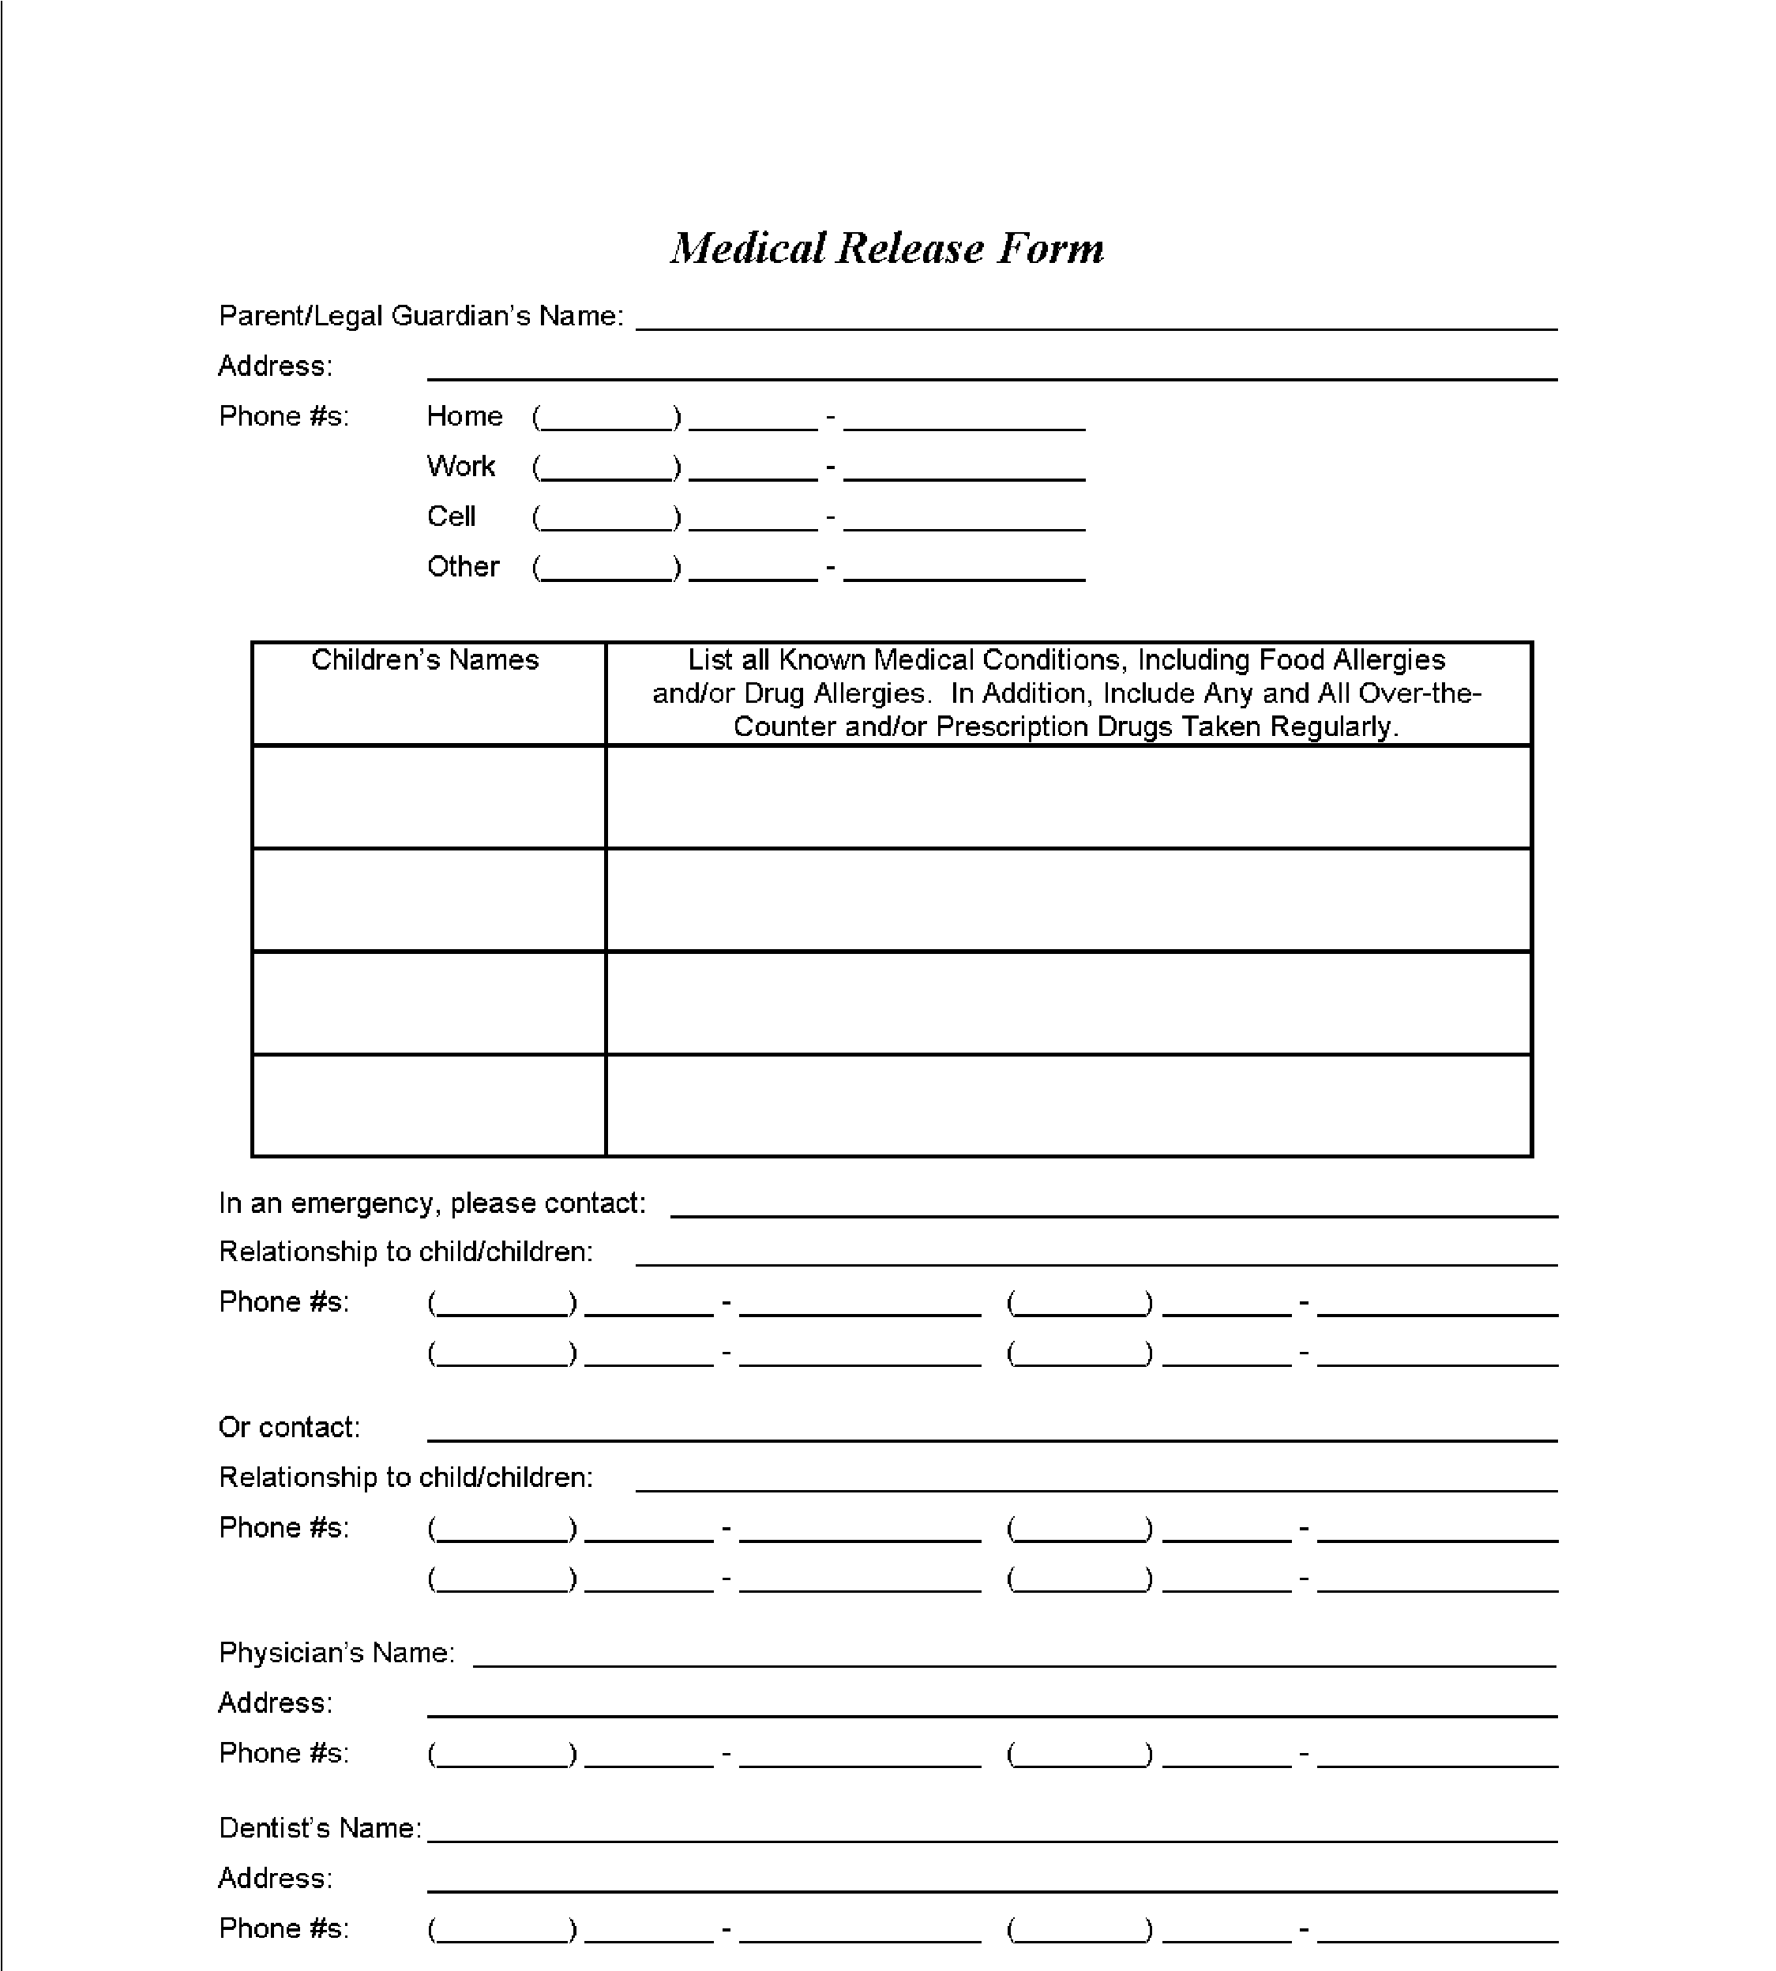
Heavens Hoofprints Equestrian

Center

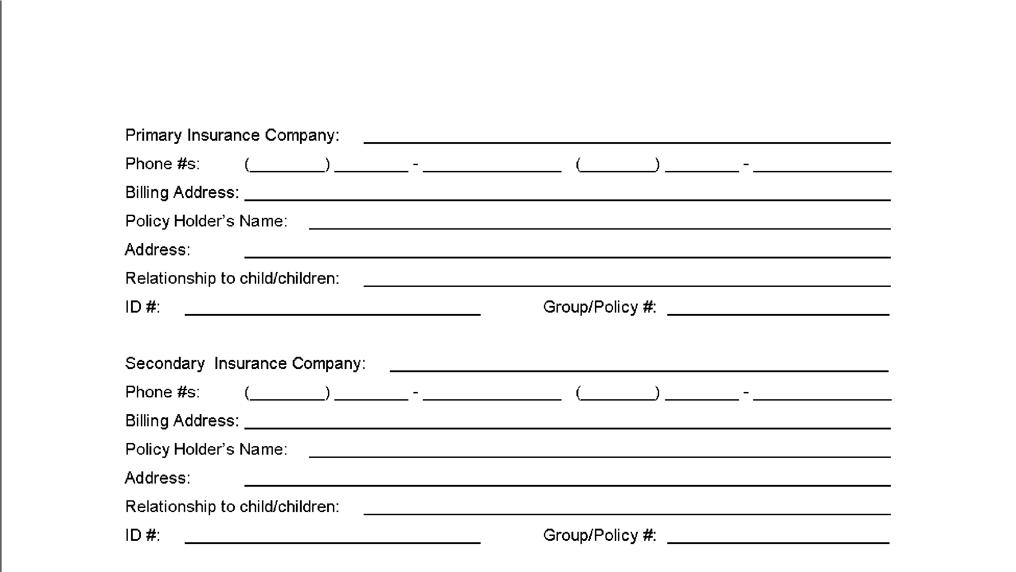

-Please remember to have all forms filled out and sent to us before your week of camp participation. You can submit your registration form and registration payment ($50) by mail at: PO BOX 243, Castaic, Ca. 91310. The remaining balance is due the first day of camp.
You may scan your completed camp forms and email to: heavenshoofprints@yahoo.com
Please submit non refundable $50 deposit by:
- Venmo, Acct name:@heavenshoofprints
- PayPal, choose friends and family, acct name: heavenshoofprints@yahoo.com
Thank you very much. We will send you a confirmation email once received.

